Planet Penny - Crochet Christmas Baubles

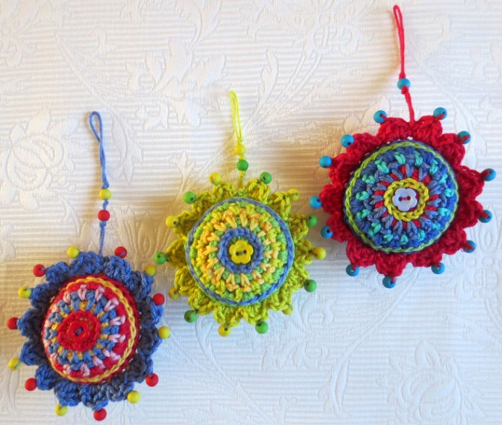
These decorative crochet balls look complicated but are relatively simple to make, and have lots of scope for adding your own individual embellishments.
Bear in mind that each round is worked between the stitches of the previous row, not in the top.
The surface chain stitch is worked from the front of the work to the back, the last stitch being pulled through the first and knotted at the back so the join is invisible.
See the pictorial notes at the end for more help.
Please note the difference between British English and American English crochet terms which I have added in brackets in the Abbreviations.
Using your own choice of yarn match the hook size to that yarn, use one size smaller than you would for a garment for a close tension (gauge) to hide the stuffing.
Materials:
DK mercerised cotton yarn
Abbreviations: ss – slip stitch, ch – chain, sp – space, dc – double crochet (US equiv. single crochet), htr - half treble ( US equiv. half double crochet) tr – treble (US equiv. double crochet), rep – repeat.
Method
Round 1: Using the ‘Magic Circle method (fig 1) make a ring with the yarn and work ch.st into the ring, then make 2nd ch st to stand as 1st tr. 13 tr into ring, join with ss into 2nd starting ch. (14 sts) Cut yarn. Pull up tail to close central hole.
Round 2: Join a new colour anywhere on the circle by inserting hook between 2 tr on the 1st round and pull through a loop. Make 2 ch. Working next sts over the tail to enclose it, make *1 dc into next tr sp, 1 ch, rep from * to end, ss into 2nd ch to complete circle, cut yarn.
Round 3: Join 3rd colour and work as Second Round, working each dc into ch sp on Round 2.
Round 4: Join next colour as before in any ch sp, work 2 ch, 1 tr into same ch sp, then work 2 tr into each ch sp to end, ss into 2nd ch to complete circle. (28st)
(See Fig 2)
Top Stitch chains. (see fig 3)
Taking your chosen contrast yarn and working from the right side, push the hook through any tr sp in first round and pull yarn through. Then work 1 ch st through each tr sp in each sp on 1st round. At the last st, cut off yarn, pull through to front. Pull the yarn through the first ch st and back through the last ch st made on to the reverse side to make the last st. Tie off
Repeat this ch st on Round 4, working between each tr stitch and finish as before.
(Note: If you find the chain join a bit fiddly, stitch it with a darning needle)
Make two.
To make up: With wrong sides together, work a round of dc sts through the back loop on the front circle and front loop on the back circle to join. Leave about 1 third open to stuff, fill with toy stuffing, then work remaining sts to close. If you wish to make a simple ball decoration this is the point to cut off yarn and fasten in the end. *For scallop edging see below.
Decorate as desired by stitching beads, buttons or any other embellishment on to the scallops. Add a hanging loop.
*Scallop Edging (see Fig 4)
Using colour of your choice start at any point on the dc joining round with a ss. Into next dc work* 1 dc, 1 htr, 1 tr, 1htr, 1dc, ss into next st. Work from * to end (14 scallops, finish with ss into 1st ss. Fasten off.
Decorate as desired with beads and buttons. Add a hanging loop.

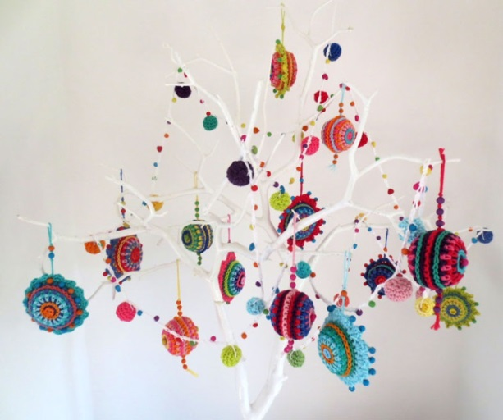
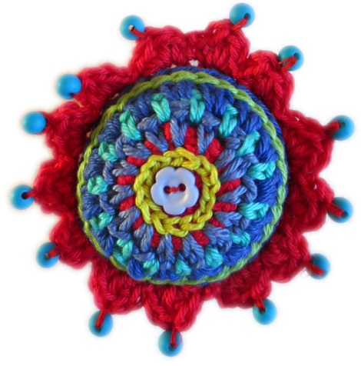

Pictorial notes
Fig 1 – Magic Circle and first round
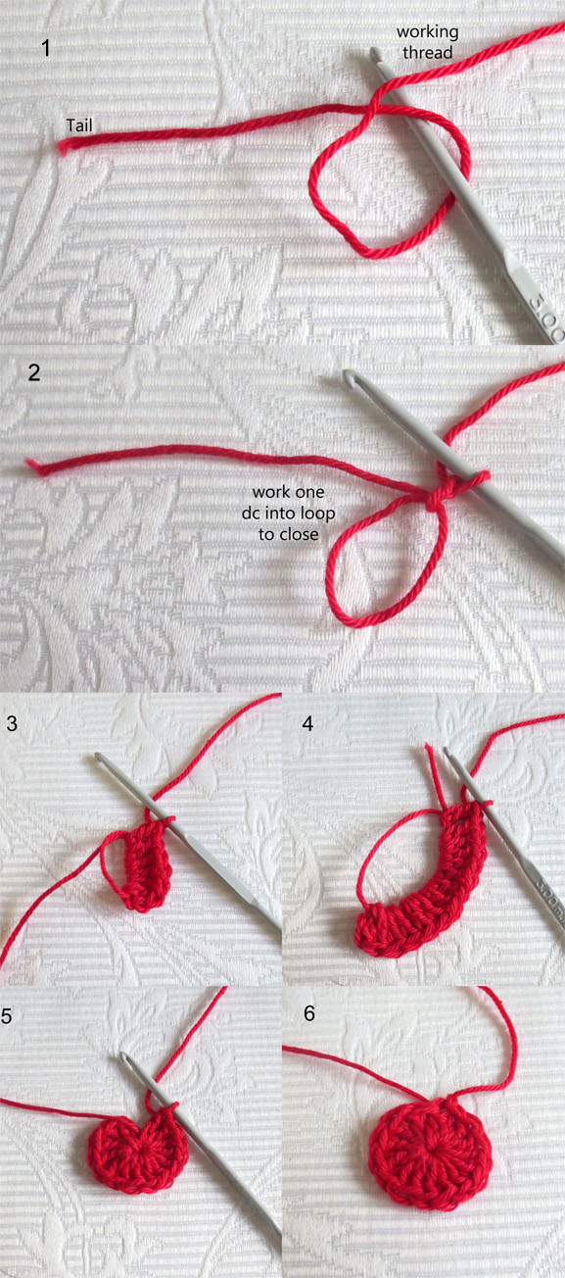
Fig 2 – Rounds 1 – 4
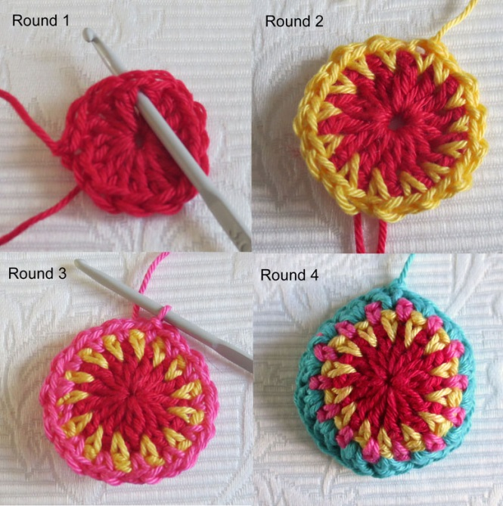

Fig 3 – Surface chain stitch
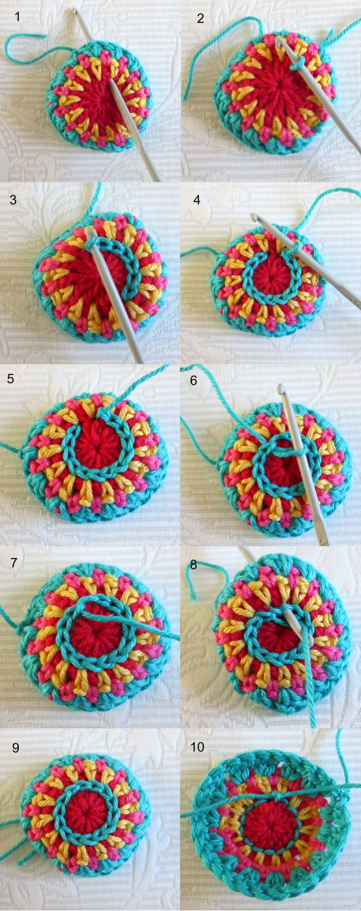

Fig 4 - Scalloped edging (demonstrated here on the straight for clarity)

