Rainbow Mice
A harvest of multicoloured crochet mice, to decorate a clock, a nursery or a craft room, or to use individually as a toy.

- Notes:
- Don’t join with a slip stitch at the end of each round. By continuing straight on the next round the piece will be a spiral rather than a series of circles. It helps to use piece of spare yarn to mark the beginning of each round so you can keep track of where you are.

- I use a 3mm hook and DK mercerised cotton when making items which require stuffing as it makes for a denser fabric. For help choosing alternative yarn and hooks see the blog post http://planetpenny.co.uk/2012/07/11/size-matters/

N.B. Crochet terms differ between countries. This pattern is written using British crochet abbreviations;
ch = chain, ss = slipstitch, dc = double crochet (UKdc2tog = double crochet 2 stitches together (decrease stitch)
American crochet conversion can be found here UK to US Crochet Terms for Patterns - EasyCrochet.com

Start with the tail, leaving enough spare yarn at the end to thread on a needle so you can fix the tail safely with a couple of stitches.
Make 22 ch. Turn and ss in each st to end.
Make 2 ch. (as you work, make sure the tail is on the outside!)

Body | 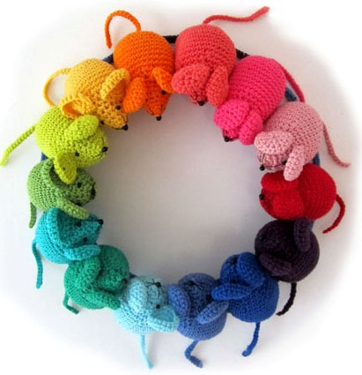
Round 1 | In 2nd st from hook, make 6 dc
Round 2 | starting with 1st dc to make a circle, work 2 dc into each st (12 st)
Round 3 | *1dc in next st, 2dc in next st; rep from * to end (18 st)
Round 4 | *1dc in next 2st,2 dc in next st; rep from * to end (24 st)
Round 5 | *1dc in next 3 st, 2 dc in next st; rep from * to end (30 st)
Round 6 | *1dc in next 4 st, 2 dc in next st; rep from * to end (36 st)
Rounds 7 – 13 | 1dc in each st
Round 14 | 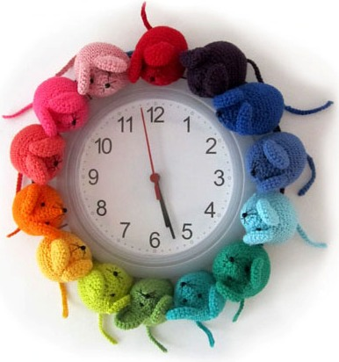  *1dc in next 4 st, dc2tog; rep from * to end (30 st)
Round 15 | * 1dc in next 3 st, dc2tog; rep from * to end (24 st)
Round 16 | 1dc in each st
Round 17 | *1dc in next 2 st, dc2tog; rep from * to end (18 st)
Round 18 | 1dc in each st
Round 19 | *1dc in next st, dc2tog; rep from * to end (12 st)
Stuff body
Rows 20-21 | 1dc in each st
Last round | - *Miss 1st st, 1dc in next st, rep from* until opening is closed.  - Fasten off and stitch in end.
Ears | Make2
Round 1 | Make 2ch, working into 2nd ch from hook make 6dc.
Rounds 2-3 | as Body pattern (18 st)
Round 4 | 1 dc in each st, fasten off leaving a tail for stitching.
Sew on ears | 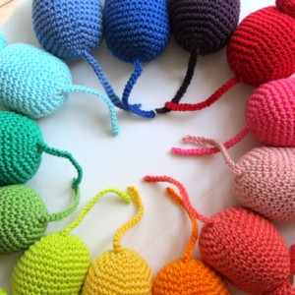  Sew on ears
Eyes & Nose | Using black thread sew on black beads for the nose and eyes  - and embroider the whiskers.  N.B. If making for a baby, small child or pet, omit the beads and embroider the features

- Now make one in every colour!

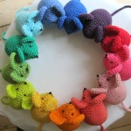
www.planetpenny.co.uk

